JAM Implementers DAO

Reflection on Decentralized Voices (DV) 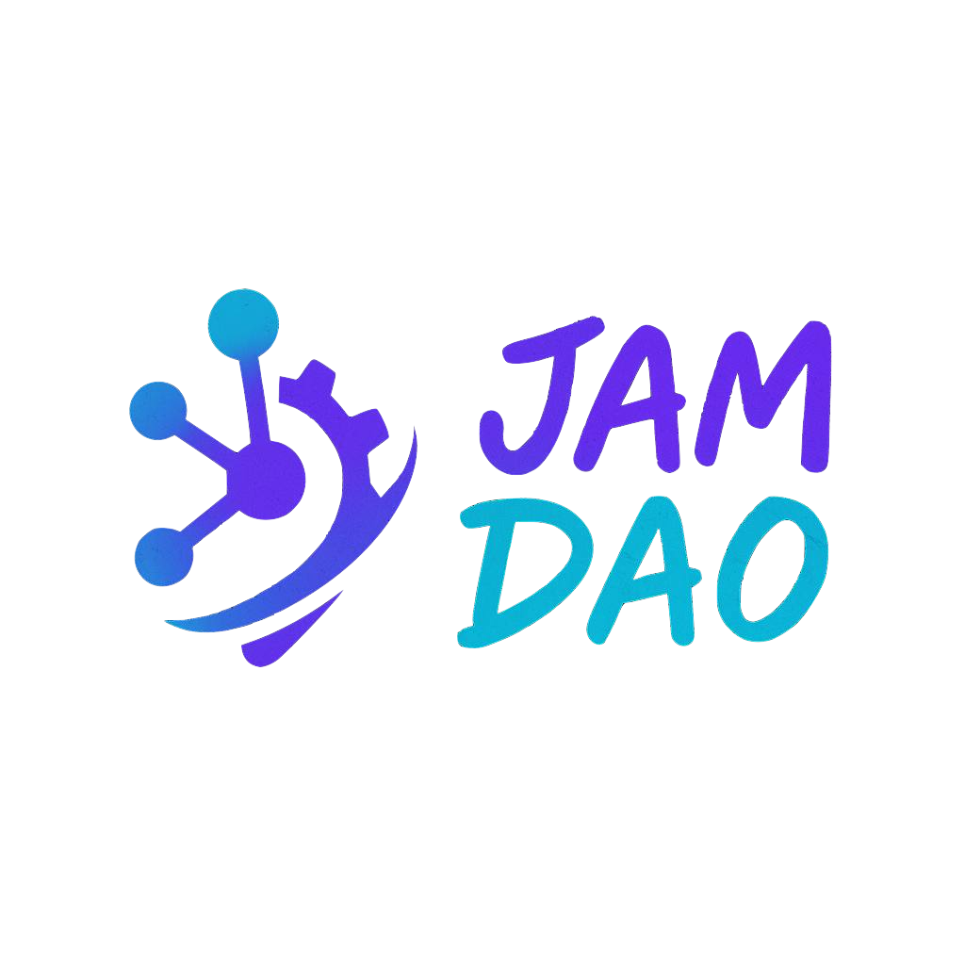Cohort 4 & Philosophy for DV Cohort 5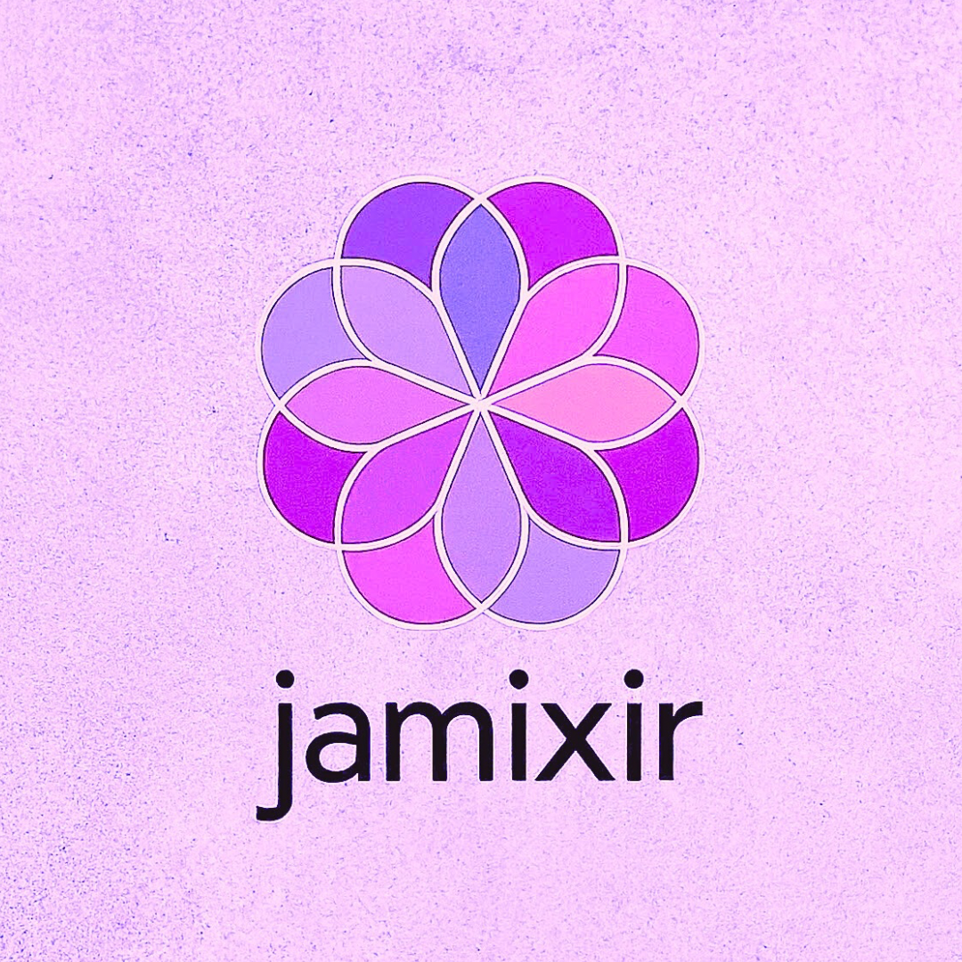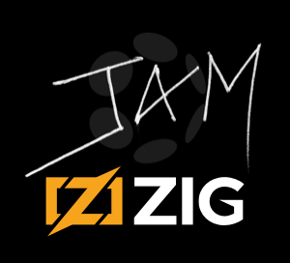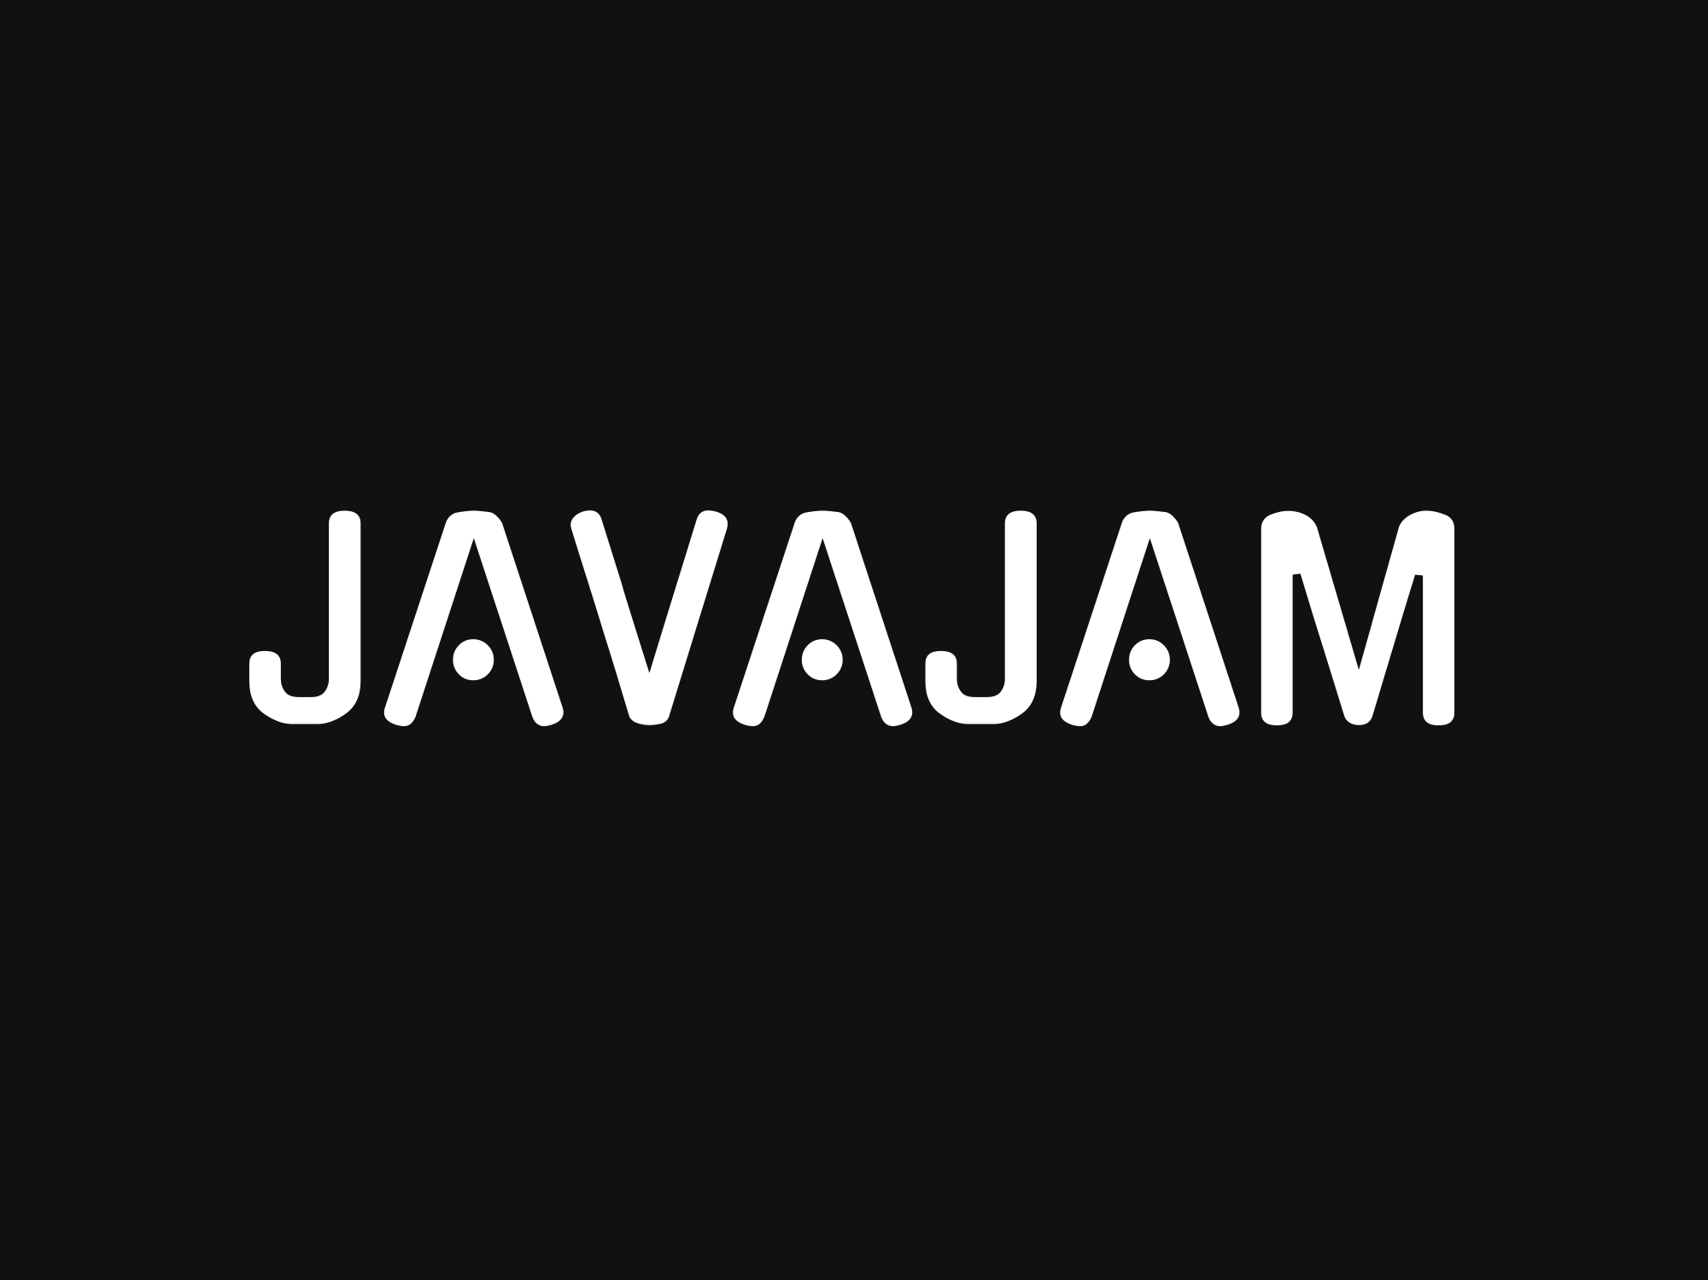

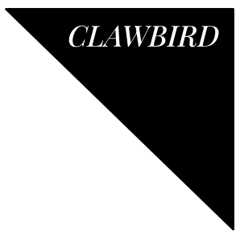

# Table of Contents

Table of Contents 2

Abstract 4

Lessons Learned (DV Cohort 4) 4

Voting Activity Summary (DV Cohort 4) 5

Figure: Comparison of DV Cohort 4 Delegates 5

AYE Vote - Merkle Mountain Belt (Polkadot Ref 1667): 5

NAY Vote - The BD Hub: Enabling Business Development Across Polkadot (Polkadot Ref 1650): 5

AYE Vote - ParaSpell✨ XCM Tools - 12 Months of Maintenance and Server cost coverage (Polkadot Ref 1641): 6

OpenGov Trends Observed During Cohort 4 6

Philosophy Going Forward 6

Main Report 8

Conflict of Interest Policy 8

Governance Updates 8

“Draft” JAM Implementers DAO Constitution 8

Updated Code of Conduct 8

Governance Participation Analysis 8

Participation Monitoring Results 9

Polkadot Governance Participation 9

Kusama Governance Participation 9

Voting Power Distribution Analysis 10

Polkadot Voting Distribution 10

Kusama Voting Distribution 10

Voting Trend Analysis: Decentralized Voices Program 11

Polkadot Voting Trends 11

Kusama Voting Trends 12

Comparative Analysis and Recommendations 12

Code of Conduct Adherence Analysis 13

Governance Rules Compliance Assessment 13

Figure: Code of Conduct Compliance Graph for JAM Implementers DAO 15

Code of Conduct Adherence Patterns 15

Areas for Improvement 16

Remediation Plan 16

On-Chain Readiness Assessment 17

Key Traits of a "Ready" On-Chain Collective 17

On-Chain vs. Off-Chain Collective Comparison 18

Self-Evaluation and Alignment 18

Process Improvements for Cohort 5 19

Enhanced Feedback Documentation 19

Standardized Proposal Evaluation Framework 19

1. Weighted Evaluation Criteria 20

2. Values Alignment Assessment 20

3. Treasury Relevance Assessment 20

Figure: Standardized Proposal Evaluation Framework 22

4. Cross-Collective Integration and Consent Verification 22

5. Formal Evaluation Process 24

6. Conflict of Interest Management 25

7. Accessibility and Capacity Support 25

8. Advanced Evaluation Methodologies 25

Multi-Step Evaluation Process 26

Voting Threshold Reforms 27

Strategic Ecosystem Engagement 27

Polkadot Agents Program Application 27

Alignment 27

Governance and Accountability Benefits 28

Operational Advantages 28

Conflict of Interest Disclosure 28

Looking Ahead to Cohort 5 29

# Abstract

JAM Implementers DAO is a working group of 30 members from 17 JAM implementation teams, where between 11 and 15 representatives were able to vote on behalf of one of the core JAM implementer teams during Decentralized Voices (DV) Cohort 4. One JAM implementer team, one vote. Our shared goal is to steward the development and direction of Polkadot and Kusama through deliberate on-chain participation, rooted in technical expertise and aligned with ecosystem needs.

We were honored to serve as a delegate in DV Cohort 4. It was our first cohort as a DAO. In that time, we’ve learned a great deal about the demands and responsibilities of being a delegate. This report reflects on those lessons, outlines our evolving decision-making philosophy, and summarizes our voting activity and priorities.

JAM Implementers DAO is comprised of teams that are published [here](https://docs.jamcha.in/dao/#members) that include: JAM DUNA, Gossamer, Jamixir, JavaJAM, JamZig, JamPy, Vinwolf, TSJam, Boka, New JAMneration, MORUM, Tessera, Fluffy Labs | typeberry, JamBrains, Clawbird, SpaceJam, and Eiger.

## Lessons Learned (DV Cohort 4)

Serving as a Decentralized Voice (DV) has been a learning experience for us, and our first cohort surfaced valuable operational and coordination insights:

* DAO Coordination: We underestimated the time, commitment, and shared responsibility required. We have now established stronger internal workflows and voting processes to respond more quickly and consistently.
* Kusama Voting Delay: We did not begin voting on Kusama referendums until a month into DV Cohort 4 due to internal technical challenges. This issue has since been resolved with the introduction of clearer delegation responsibilities.
* Proposal Feedback Loops: Our process for communicating with proposers was ad hoc. For DV Cohort 5, we are introducing a DAO Assistant to facilitate proactive proposer engagement and follow-up.
* Voting Threshold Calibration: We initially relied on a fixed quorum for internal approvals. We're recalibrating our thresholds to better account for the proportion of AYE and NAY votes relative to total participation — aiming to make decisions more responsive without compromising DAO integrity.

## Voting Activity Summary (DV Cohort 4)

Across DV Cohort 4, we voted on 170+ proposals (162+ on Polkadot, 33+ on Kusama as at 2nd August 2025) while voting ABSTAIN on proposals where a conflict of interest or a lack of consensus occurred.

## 

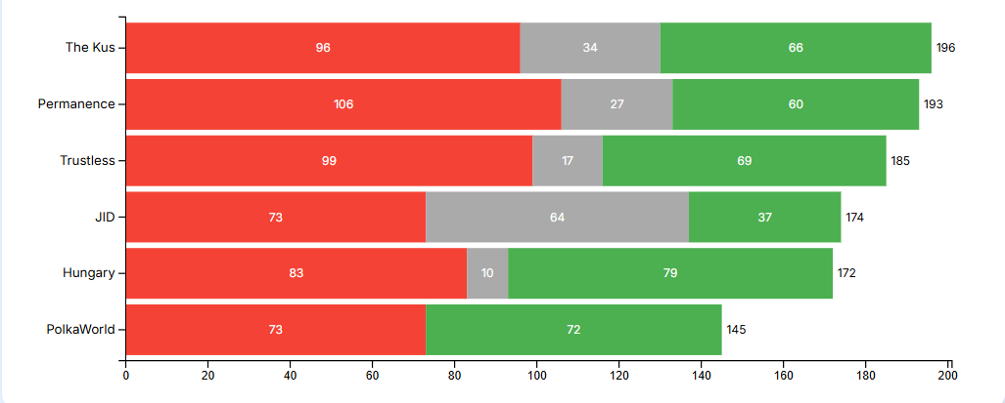

##### Figure: Comparison of DV Cohort 4 Delegates

Here are three examples of our voting impact and rationale:

#### AYE Vote - Merkle Mountain Belt (Polkadot [Ref 1667](https://polkadot.polkassembly.io/referenda/1667)):

Initially rejected over ROI concerns, we shifted to support after deeper engagement, viewing MMB as a strategic investment in future-proofing Polkadot’s infrastructure.

#### NAY Vote - The BD Hub: Enabling Business Development Across Polkadot (Polkadot [Ref 1650](https://polkadot.polkassembly.io/referenda/1650)):

While the proposal had strong testimonials, we flagged centralization risks, lack of KPIs, and unclear coordination. We favored more decentralized, metrics-driven BD approaches aligned with Polkadot’s ethos.

#### AYE Vote - ParaSpell✨ XCM Tools - 12 Months of Maintenance and Server cost coverage (Polkadot [Ref 1641](https://polkadot.polkassembly.io/referenda/1641)):

We supported this proposal because it directly improved developer access to XCM, with support for cross-chain swaps, DryRunAPI, and XCM v5. We saw clear traction from Multix and Turtle, and believed the SDK meaningfully lowered the barrier to cross-chain building.

## OpenGov Trends Observed During Cohort 4

During our participation in Cohort 4, we observed several significant trends in the OpenGov ecosystem:

1. Treasury Stewardship Gap: Significant imbalance in governance attention between Polkadot ($102.48M treasury) and Kusama ($7.4M treasury), with participation rates of 48% and 33% respectively.
2. Voting Power Concentration: On Polkadot, two members accounted for 38% of votes; on Kusama, one member accounted for 54% of votes, highlighting centralization risks.
3. Proposal Quality Variance: Wide variation in proposal quality, documentation, and follow-through, suggesting the need for standardized evaluation frameworks.

These trends directly informed our Philosophy Going Forward and the development of our Standardized Proposal Evaluation Framework.

## Philosophy Going Forward

Our core voting principles are:

1. Ecosystem Fit Over Individual Vision  
   We will continue to prioritize funding that aligns with Polkadot’s technical roadmap, community needs, and long-term sustainability, not just strong ideas in isolation.
2. Measured Accountability  
   We ask hard questions around metrics, adoption, cost-effectiveness, and overlap. Treasury requests should have clear goals, milestones, and relevance.
3. Empowering Builders  
   We are biased toward supporting infrastructure that reduces friction for developers, especially around interoperability (XCM), governance, tooling, and network scalability.
4. Curiosity & Constructive Skepticism  
   We try to engage proposers with honest feedback. Even when we vote NAY, our goal is to support proposals that come back stronger and more focused.

These principles are implemented through our detailed Standardized Proposal Evaluation Framework section and guided by our section containing the Self-Evaluation and Alignment process, which ensures our decisions remain consistent with ecosystem values and technical priorities.

# Main Report

## Conflict of Interest Policy

We have adopted a clear and proactive conflict of interest policy: If any member identifies even the slightest conflict in a proposal - personal, financial, or organizational, they recuse themselves from the vote. This standard has been applied consistently throughout our participation in DV Cohort 4, ensuring our voice reflects the network’s best interest, not private agendas.

## Governance Updates

### “Draft” JAM Implementers DAO Constitution

One member prepared a comprehensive “Draft” JAM Implementers DAO Constitution recently that is still undergoing internal review. Initial feedback has rejected it, as it needs to be significantly overhauled to include more diagrams and less text, particularly for lengthy rules. It needs non-DAO specific content to be removed and migrated elsewhere if relevant for the ecosystem. Despite its shortcomings so far, the author has shared it publicly for the community here in [Pull Request #57](https://github.com/JamBrains/jam-docs/pull/57). It was inspired by the second draft of the Polkadot DAO Constitution that they forked and updated to a third draft [here](https://gist.github.com/ltfschoen/6bcdf6ca9545d1e7acd2e38f0d519fe4) along with Polkadot Human Rights Definitions that they forked [here](https://gist.github.com/ltfschoen/76addc970e8ae7b95a43d5d523404f2b).

### Updated Code of Conduct

The same Pull Request includes significant updates to our Code of Conduct, which now features specific guidelines for proposers seeking treasury funding. These guidelines aim to standardize proposal formats, clarify expectations, and streamline the evaluation process for all stakeholders.

## Governance Participation Analysis

Our participation monitoring reveals a clear trend: JAM Implementers DAO members have significantly prioritized Polkadot governance participation over Kusama. This allocation of attention requires rebalancing, especially considering the substantial treasury resources at stake where Polkadot treasury has approximately $102.48M, compared to $7.4M in the Kusama treasury according to <https://www.dotreasury.com> on 2nd August 2025.

### Participation Monitoring Results

As part of our commitment to governance, health and transparency, we have implemented regular participation monitoring across both Polkadot and Kusama networks. This data-driven approach allows us to identify participation patterns, address governance risks, and ensure our voting power is being exercised responsibly.

#### Polkadot Governance Participation

Our most recent participation statistics for Polkadot governance show:

| **Participation Level** | **Members** | **Percentage of Total** |
| --- | --- | --- |
| **High (75-100%)** | 2 | 14.3% |
| **Medium (40-74%)** | 4 | 28.6% |
| **Low (1-39%)** | 5 | 35.7% |
| **None (0%)** | 3 | 21.4% |

Key Observations:

* Two members maintained exceptional participation (91-100%)
* Four members showed strong engagement (40-60%)
* Five members had limited but measurable participation (1-39%)
* Three members had zero participation
* Overall participation averaged approximately 48%, exceeding our minimum threshold of 45%

#### Kusama Governance Participation

Our participation in Kusama governance shows varying levels of engagement:

| **Participation Level** | **Members** | **Percentage of Total** |
| --- | --- | --- |
| **High (75-100%)** | 1 | 9.1% |
| **Medium (30-74%)** | 4 | 36.4% |
| **Low (1-29%)** | 1 | 9.1% |
| **None (0%)** | 5 | 45.4% |

Key Observations:

* One member maintained high participation (77.8%)
* Four members showed moderate participation (30-74%)
* One member had limited participation (1-29%)
* Five members had zero participation in Kusama governance
* Overall participation averaged approximately 33%, which falls below our minimum threshold

### Voting Power Distribution Analysis

Our voting power distribution analysis reveals important patterns that inform our governance reforms:

#### Polkadot Voting Distribution

* Vote Concentration: Two members accounted for approximately 38% of all votes cast
* Quorum Achievement: 91% of proposals achieved our minimum participation threshold
* Voting Consensus: 82% of proposals achieved supermajority consensus
* Recusal Patterns: Recusals were appropriately distributed across proposal types with no concerning patterns

#### Kusama Voting Distribution

* Vote Concentration: One member accounted for approximately 54% of all votes cast
* Quorum Achievement: Only 33% of proposals achieved our minimum participation threshold
* Voting Consensus: Despite limited participation, 67% of voted proposals achieved consensus
* Treasury Stewardship Gap: Significant disparity in participation between Polkadot and Kusama governance creates a concerning stewardship gap for Kusama's $7.4M treasury
* Improvement Needed: Participation is better than initially reported, but we still need to implement:
  + Mandatory participation requirements for all members
  + Weekly participation reports with public accountability
  + Enhanced notification systems for upcoming votes
  + Potential rotation of inactive members with more engaged contributors
  + Balanced governance attention across both networks proportional to their respective treasury sizes

%%{init: {'theme': 'base', 'themeVariables': { 'primaryColor': '#5D67FF', 'primaryTextColor': '#fff', 'primaryBorderColor': '#5D67FF', 'lineColor': '#5D67FF', 'secondaryColor': '#E27D60', 'tertiaryColor': '#41B3A3' }}}%%
flowchart LR
    A["Total Voting Power"] --> B["Polkadot"]
    A --> C["Kusama"]
    B --> D["Top 2 Members: 38%"]
    B --> E["Other Members: 62%"]
    C --> F["Top Member: 54%"]
    C --> G["Other Members: 46%"]
    
    style A fill:#6772e5,stroke:#333,stroke-width:1px
    style B fill:#5D67FF,stroke:#333,stroke-width:1px
    style C fill:#E27D60,stroke:#333,stroke-width:1px
    style D fill:#85D2EF,stroke:#333,stroke-width:1px
    style E fill:#41B3A3,stroke:#333,stroke-width:1px
    style F fill:#E8A87C,stroke:#333,stroke-width:1px
    style G fill:#C38D9E,stroke:#333,stroke-width:1px  
Figure: Spread of JAM Implementers DAO Total Voting Power

### Voting Trend Analysis: Decentralized Voices Program

As part of our responsibilities in the Web3 Foundation's Decentralized Voices Cohort 4, JAM Implementers DAO has been entrusted with significant voting power across both Polkadot and Kusama networks. The following analysis examines our actual voting patterns based on on-chain data to identify key trends and areas for improvement.

#### Polkadot Voting Trends

Our analysis of Polkadot voting history reveals several important patterns:

* Conviction Evolution Pattern: We observed a clear evolution in conviction usage:
  + Early votes (April 2025) consistently used conviction level 6
  + Mid-period votes (June 2025) shifted to conviction level 4
  + This pattern suggests a strategic shift from maximum conviction to a balanced approach
* Conviction Consistency: We maintained consistent conviction levels for definitive positions (AYE/NAY) within time periods:
  + April-May 2025: Exclusively conviction 6
  + June-August 2025: Exclusively conviction 4
  + No mixing of conviction levels 4 and 6 on the same proposal
* Valid vs. Invalid Votes: Invalid votes were primarily due to expired votes rather than technical errors, with no pattern of specific vote types (AYE/NAY/ABSTAIN) being more likely to expire
* Strategic Vote Distribution: Approximately 35% "AYE" votes versus 65% "NAY" votes, indicating a careful evaluation process rather than default approval

#### Kusama Voting Trends

Analysis of our Kusama voting history reveals a different pattern:

* Limited Conviction Variation: Unlike Polkadot, Kusama votes showed minimal variation in conviction levels:
  + Definitive votes (AYE/NAY) consistently used conviction 4
  + No evidence of conviction 6 usage at any point in the voting history
* High Abstention Rate: Approximately 70% of our Kusama votes were ABSTAIN, compared to only about 25% on Polkadot
* Temporal Clustering of Definitive Votes: The few definitive votes (with conviction 4) were clustered around specific time periods (late June and mid-July 2025) rather than distributed evenly throughout the voting history due to the Kusama Voting Delay.
* Valid vs. Invalid Pattern: Similar to Polkadot, invalid votes were due to expiration rather than technical errors, with no pattern of specific vote types being more likely to expire

#### Comparative Analysis and Recommendations

The voting data confirms our earlier participation analysis findings and highlights several key insights:

* Strategic Conviction Evolution: Our Polkadot voting strategy evolved from maximum conviction (6) with smaller amounts to a more balanced approach (conviction 4) with larger amounts. This strategic evolution was absent in Kusama governance, where conviction levels remained static.
* Network Prioritization Gap: Our voting behavior demonstrates a clear prioritization of Polkadot governance over Kusama, with more decisive voting, higher overall conviction impact, and more consistent participation.
* Treasury Stewardship Imbalance: Given Kusama's $7.4M treasury, our high abstention rate (70% vs 25% on Polkadot) represents a potential governance risk that requires immediate attention.
* Conviction Strategy Disparity: The significant difference in conviction approach between networks suggests different levels of confidence or commitment:
  + Polkadot: Strategic evolution from conviction 6 to conviction 4 with increased amounts
  + Kusama: Static approach with conviction 4 for definitive votes only
* Recommended Actions:
  + Implement a balanced conviction strategy across both networks with clear guidelines for when to use each conviction level
  + Reduce abstention rates on Kusama through better proposal analysis and dedicated resources
  + Establish minimum participation requirements for both networks with network-specific targets
  + Create specialized working groups for each network to ensure equal attention
  + Develop expertise in Kusama-specific proposals to enable more definitive voting positions
  + Document conviction strategy decisions to ensure consistency and transparency

This voting trend analysis will guide our governance improvement efforts as we work to fulfill our responsibilities as stewards of both the Polkadot ($102.48M) and Kusama ($7.4M) treasuries.

## Code of Conduct Adherence Analysis

As part of our commitment to transparent self-assessment, we have evaluated our adherence to the JAM Implementers DAO Code of Conduct and governance rules that were established at the beginning of our participation in the Decentralized Voices Cohort 4 program.

### Governance Rules Compliance Assessment

| **Governance Rule** | **Compliance Status** | **Evidence** |
| --- | --- | --- |
| **MIN_PARTICIPATION: 45%** | Partially Met | Polkadot participation (48%) exceeded threshold; Kusama participation (33%) fell below |
| **Voting Threshold: 51%** | Met | Both networks achieved >51% consensus on voted proposals |
| **Conflict of Interest Policy** | Met | Consistent recusal pattern observed in voting records |
| **Transparency Requirements** | Partially Met | All votes publicly recorded with most including rationales |

##### %%{init: {'theme': 'base', 'themeVariables': { 'primaryColor': '#5D67FF', 'primaryTextColor': '#000', 'primaryBorderColor': '#5D67FF', 'lineColor': '#5D67FF', 'secondaryColor': '#E27D60', 'tertiaryColor': '#41B3A3' }}}%% pie title Code of Conduct Compliance "Fully Met (67%)" : 67 "Partially Met (25%)" : 25 "Not Met (8%)" : 8 Figure: Code of Conduct Compliance Graph for JAM Implementers DAO

### Code of Conduct Adherence Patterns

Our analysis identified several patterns in how we have adhered to the Code of Conduct:

* Professional Representation: Members have consistently represented the JAM Implementers DAO professionally in public forums and governance discussions, with no documented instances of unprofessional conduct.
* Participation Imbalance: The "Actively Participate" directive has been unevenly followed, with strong engagement on Polkadot governance but insufficient participation on Kusama governance.
* Information Accuracy: No instances of misinformation spread by our members were identified, maintaining the integrity of our communications.
* Unauthorized Representation: No documented cases of members entering unauthorized partnerships or making unauthorized commitments on behalf of the JAM Implementers DAO.
* Constructive Communication: The "No constant ranting/complaining" rule has been consistently followed, with governance feedback remaining constructive even when critical.

### Areas for Improvement

Based on our Code of Conduct and governance rules, we have identified these key areas for improvement:

* Participation Incentives: While our Code of Conduct states "Members may be removed due to lack of voting behavior in order to meet MIN_PARTICIPATION objectives", we have implemented this provision in a limited capacity. In one notable instance, when several members failed to vote within a 7-day period causing the DAO to miss its 45% participation threshold, we initiated a transparent process where members with zero participation were identified through the participation tracking system and given notice before any action was taken with some members voluntarily requesting to have their voting rights adjusted. Alternative arrangements were made where team representatives could be replaced by other team members with more availability. After adjusting their voting rights those members retained "participant" status so they could continue to observe and comment on proposals.

This experience highlighted the need for a more formalized process that balances accountability with fairness, prevents arbitrary removal of voting rights, and accommodates varying levels of time commitment from members.

* Balanced Network Attention: Our commitment to "Actively Participate" has been applied inconsistently between networks, requiring specific mechanisms to ensure equal governance attention.
* Internal Discussion Depth: While we have maintained the required voting thresholds, the quality and depth of internal discussions prior to voting has varied significantly between high-profile and routine proposals.
* Conflict of Interest Documentation: The proposed new “Draft” JAM Implementers DAO Constitution now addresses this gap with a standardized documentation process that includes mandatory pre-evaluation disclosures, recusal requirements, public documentation of all recusals with justifications, and prohibitions on consulting for proposals members will evaluate.

### Remediation Plan

To address these Code of Conduct adherence gaps, we propose:

* Formal review process should be implemented for members with zero participation, with clear consequences as outlined in our governance documents
* Network-specific participation requirements should be implemented rather than a single threshold
* Standard template should be created for declaration of conflicts of interest
* Consistency in depth of proposal discussions should be developed into a framework to ensure consistent depth of analysis across all proposals

This adherence analysis will be conducted quarterly to ensure continuous improvement in our governance practices and alignment with our stated values and Code of Conduct.

## On-Chain Readiness Assessment

### Key Traits of a "Ready" On-Chain Collective

As we consider our path forward, we've identified the following key traits that indicate readiness for on-chain formalization, ordered from most to least important based on our assessment:

* Active governance participation - Reliable voting record with sufficient participants to maintain quorum
* Transparent conflict disclosure - Proactive declaration of conflicts before abstaining from votes
* Technical competence - Demonstrated ability to evaluate security implications
* Emergency response protocols - Documented procedures for time-sensitive security incidents
* Transparent decision history - Accessible record of past decisions with clear reasoning
* Dispute resolution mechanisms - Structured processes to break deadlocks and resolve disagreements
* Constitutional governance - Formal framework ensuring consistent rule application across membership changes
* Participation metrics - Tracked voting activity and response times to prevent governance paralysis

The “Draft” JAM Implementers DAO Constitution serves as the formal framework. This constitutional approach ensures that governance practices remain consistent even as individual participants change over time.

### On-Chain vs. Off-Chain Collective Comparison

| **Aspect** | **On-Chain Collective** | **Off-Chain Collective (Multisig)** |
| --- | --- | --- |
| **Transparency** | Full on-chain record of all votes and actions | Limited transparency, depends on manual reporting |
| **Accountability** | Code-enforced rules and limits | Social accountability only |
| **Treasury Control** | Direct access through collective pallet | Indirect access through multisig |
| **Flexibility** | Changes require runtime upgrades | Adaptable processes without chain changes |
| **Technical Barrier** | Requires technical expertise | Lower technical requirements |
| **Governance Capture Protection** | Code-enforced limits on membership and voting | Relies on social trust and manual oversight |
| **Execution Speed** | Potentially slower due to on-chain processes | Potentially faster for emergency actions |
| **Security Risk** | Higher stakes, more scrutiny | Lower visibility, potentially less scrutiny |

### Self-Evaluation and Alignment

Our ongoing self-assessment indicates strong alignment with:

* Polkadot and Kusama values that serve as foundational ecosystem principles
* Web3 tenets that serve as the broader philosophical framework
* Technical Fellowship manifesto
* Ambassador Fellowship manifesto
* “Draft” Polkadot DAO Constitution
* JAM Service Profile values
* “Draft” JAM Implementers DAO Constitution

We comprise members who uphold the principles of both the Technical Fellowship manifesto and the Ambassador Fellowship manifesto with continuous representation since the original inception of each program.

This multi-dimensional alignment across technical, community, and governance domains positions JAM Implementers DAO uniquely within the ecosystem. We continue to evaluate our readiness for potential on-chain formalization while strengthening our current multisig-based governance processes. This balanced approach ensures we maintain operational effectiveness while preparing for future evolution.

## Process Improvements for Cohort 5

Based on feedback and our own observations during Cohort 4, we are implementing several key process improvements:

### Enhanced Feedback Documentation

* Comprehensive Justifications: Each proposal should include thorough documentation of reasoning for AYE, NAY, and ABSTAIN votes, even when consensus seems clear
* Balanced Perspectives: Each proposal should document both supporting arguments and potential concerns, regardless of whether the final collective vote is AYE, NAY, or ABSTAIN
* Transparent Evaluation Framework: Consistent criteria documentation should be publicly provided across all proposals to avoid incomplete assessments and ensure accountability

### Standardized Proposal Evaluation Framework

Drawing from established procurement best practices, we are endeavoring to implement a structured evaluation framework for all proposals:

#### 1. Weighted Evaluation Criteria

* Technical Merit (25%): Quality, innovation, and technical soundness of the solution
* Ecosystem Alignment (25%): Fit with JAM protocol requirements and the technical roadmap and ecosystem needs of Polkadot and Kusama
* Sustainability (20%): Long-term maintenance plan, path to self-sufficiency, and reduced reliance on treasury funding
* Value-Add & Efficiency (15%): Differentiated benefits to the ecosystem, practical impact relative to cost, and resource efficiency
* Delivery Competence (15%): Team expertise, proven track record, and operational capacity

These weightings serve as our standard baseline but may be adjusted based on proposal track/origin, funding size thresholds, and following public notification of any changes at least 28 days prior to applying to future evaluations to maintain transparency and allow adequate preparation time.

#### 2. Values Alignment Assessment

Each proposal is also evaluated against our core values and principles that are listed in the Self-Evaluation and Alignment section of this report.

This multi-dimensional alignment assessment ensures proposals contribute positively across technical, community, and governance domains within the ecosystem.

#### 3. Treasury Relevance Assessment

As a prerequisite to the weighted evaluation, each proposal is first screened for its appropriateness for treasury funding:

* Public good characteristics: Benefits that accrue to the ecosystem rather than primarily to private investors
* Funding fit: Suitability for treasury funding rather than venture capital or other private investment sources
* Prior funding scrutiny: Careful review of teams that have received substantial prior treasury funding but pivoted or failed to deliver, as these should typically seek venture capital rather than continued treasury support
* Multiplier effect: Potential to generate broader ecosystem value beyond direct deliverables
* Sustainability model: Clear path to sustainability that does not rely on perpetual treasury funding

This assessment ensures treasury resources are directed toward proposals that genuinely require public funding and could not be better served through private capital markets. Proposals that fail this initial assessment may be redirected to more appropriate funding sources before proceeding to the weighted evaluation stage.

%%{init: {'theme': 'base', 'themeVariables': { 'primaryColor': '#5D67FF', 'primaryTextColor': '#fff', 'primaryBorderColor': '#5D67FF', 'lineColor': '#5D67FF', 'secondaryColor': '#E27D60', 'tertiaryColor': '#41B3A3' }}}%%
flowchart TD
    A[New Proposal] --> B{Initial Screening}
    B -->|Passes| C[Detailed Evaluation]
    B -->|Fails| D[Abstain or NAY]
    C --> E{Values Alignment}
    E -->|High| F[Treasury Relevance]
    E -->|Low| D
    F -->|High| G[Technical Assessment]
    F -->|Low| D
    G -->|Passes| H[AYE Vote]
    G -->|Fails| D
    
    style A fill:#6772e5,stroke:#333,stroke-width:1px
    style B fill:#5D67FF,stroke:#333,stroke-width:1px
    style C fill:#41B3A3,stroke:#333,stroke-width:1px
    style D fill:#E27D60,stroke:#333,stroke-width:1px
    style E fill:#5D67FF,stroke:#333,stroke-width:1px
    style F fill:#41B3A3,stroke:#333,stroke-width:1px
    style G fill:#85D2EF,stroke:#333,stroke-width:1px
    style H fill:#4CAF50,stroke:#333,stroke-width:1px

##### Figure: Standardized Proposal Evaluation Framework

#### 4. Cross-Collective Integration and Consent Verification

To enhance governance integrity and cross-collective collaboration, we are exploring integration of the "AND Gate" for EnsureOrigin feature of [Polkadot SDK Pull Request #9048](https://github.com/paritytech/polkadot-sdk/pull/9048) that proposes to address [Polkadot SDK Issue #369](https://github.com/paritytech/polkadot-sdk/issues/369) by Dr Gavin Wood and provides a framework for multi-collective consent verification:

* Multi-Collective Consent Verification: Technical solutions implemented that require explicit consent from multiple relevant collectives or their tiered members before certain actions may proceed
* Programmatic Consent: Using on-chain logic to verify that all required approvals have been properly obtained
* Transparent Audit Trail: Creating immutable on-chain records of all consent expressions across multiple governance bodies
* Governance Resilience and Error Prevention: Adaptive quorum mechanisms, signer accountability metrics, and programmatic safeguards to prevent inactive signer bottlenecks, misinterpretation of complex consent requirements, and ensure the collective may adapt to changing circumstances while maintaining integrity.

This cross-collective consent mechanism approach would be particularly valuable for proposals that span multiple domains requiring diverse levels of expertise from different collectives, impact multiple stakeholders, and involve significant treasury expenditures, since we may ensure proposals receive proper evaluation from all relevant governance bodies while maintaining clear accountability and preventing governance paralysis.

Additionally, we believe that implementing [Polkadot SDK Issue #374](https://github.com/paritytech/polkadot-sdk/issues/374) "Approval vote alternatives for referendums" by Dr Gavin Wood would significantly enhance our governance capabilities. This feature would transform referendums from binary AYE/NAY/ABSTAIN decisions into multiple-choice affairs with an approval voting mechanism, allowing for:

* Compromise Solutions: The ability to propose alternative implementations or approaches to the same problem, increasing the likelihood of finding consensus
* Efficient Resource Allocation: Preventing duplicate proposals addressing the same issue through different approaches
* Reduced Governance Friction: Allowing the community to select the most preferred implementation rather than rejecting proposals outright
* Deposit Optimization: Leveraging the deposit mechanism to prioritize serious alternatives while discouraging spam through deposit burning for non-winning options

The deposit optimization mechanism would be particularly effective at addressing the growing problem of low-quality Wish For Change (WFC) referenda, particularly on Kusama, that lack substantive content, proper formatting, or clear objectives. Recent examples include proposals containing only a URL to social media posts without explanation, proposals with no title or minimal description, and proposals that should have been directed to off-chain discussion forums first. These low-effort submissions consume valuable governance attention and dilute the quality of on-chain discourse.

If [Polkadot SDK Issue #374](https://github.com/paritytech/polkadot-sdk/issues/374) is implemented, then:

* All proposals would require a meaningful initial deposit
* Deposits for non-winning alternatives would be burned
* Economic disincentive of this solution would naturally filter out proposals that are not serious or well-formulated
* Proposers of WFC referenda in particular would be motivated to consolidate similar ideas into stronger and more comprehensive proposals rather than submitting multiple competing referenda

We recommend prioritizing work on this feature after the "AND Gate" implementation, as it would create a more nuanced and representative governance system that better reflects the complexity of decisions facing the ecosystem while simultaneously improving the overall quality of governance proposals.

#### 5. Formal Evaluation Process

* Pre-Evaluation Screening: Initial compliance check against minimum requirements
* Independent Assessments: Multiple JAM Implementers DAO members evaluate independently before group discussion
* Structured Deliberation: Facilitated discussion using standardized evaluation templates
* Documented Decision: Comprehensive record of evaluation with scores and justifications
* Feedback Loop: Structured feedback to proposers with improvement opportunities

#### 6. Conflict of Interest Management

* Mandatory Disclosure: Required declaration of any potential conflicts before evaluation
* Recusal Protocol: Clear process for when members must abstain from evaluation
* Transparency Reporting: Public documentation of all recusals and their reasons

#### 7. Accessibility and Capacity Support

* Proportional Requirements: Compliance requirements should be documented and scaled appropriately to proposal size and complexity
* Educational Resources: Publicly available guidance materials should be provided to help all proposers understand and meet evaluation standards
* Technical Documentation: Clear templates and examples should be available to all participants regardless of team size or experience
* Equal Access Framework: Evaluation processes should not inadvertently disadvantage smaller teams or solo contributors while maintaining consistent standards

This approach ensures evaluation processes remain fair and consistent while recognizing that documentation burdens should be proportional to proposal size and complexity. All support resources should be made available to all proposers equally, maintaining a level playing field while reducing unnecessary barriers to participation.

#### 8. Advanced Evaluation Methodologies

We will endeavor to employ different evaluation methodologies based on proposal type, complexity, and value:

* Matrix Comparison: Standard proposals could be evaluated using a matrix comparison approach where each criterion is independently scored by evaluators before group discussion, with documented justifications for each score to prevent groupthink and ensure diverse perspectives are considered.
* Proposal Assessment: OpenGov typically presents individual proposals rather than competitive bids so each proposal should be evaluated on its absolute merit against established criteria rather than comparatively. This includes assessing value-for-treasury against historical precedents, market rates, and expected ecosystem impact to ensure responsible stewardship of our limited resources. If OpenGov proposals contain multiple competing bids or options requiring comparative evaluation, the Inverse Cost Assessment methodology outlined in the “Draft” JAM Implementers DAO Constitution may be applied to ensure objective price comparison while maintaining quality standards.
* Quality-First Evaluation: Complex or high-value proposals could use a two-envelope system where non-price criteria are evaluated first and only the highest-rated proposal's price envelope is opened for negotiation to ensure quality remains the primary consideration. Proposals scoring below 50% on any criterion should be eliminated before price consideration.

The methodology selection should be documented and justified as part of each evaluation record, ensuring transparency in our decision-making process.

This framework ensures consistent, fair evaluation while maintaining flexibility for the unique aspects of each proposal. All evaluation criteria and weightings should be published in advance to help proposers prepare their strongest submissions.

### Multi-Step Evaluation Process

* Initial Assessment: First evaluation is conducted when a proposal is submitted, with our individual JAM Implementers DAO members voting independently (AYE, NAY, or RECUSE) in a dedicated Discord thread
* Proposer Feedback Integration: Dedicated review period after proposer responses to consider adjustments and clarifications
* Re-evaluation Mechanism: Formal process to update our position based on meaningful proposal improvements
* Automated Decision Execution: After a configurable waiting period (typically several days), our governance bot calculates the collective decision based on:
  + Minimum participation threshold (configurable percentage of eligible voters)
  + Supermajority threshold (configurable, default 66%)
  + Two-phase voting with initial position and potential re-evaluation
* Transparent Record-Keeping: All votes are recorded with immutable on-chain transactions, creating a permanent audit trail of governance decisions
* Participation Monitoring: Automatic alerts when participation falls below required thresholds, with clear metrics on remaining time and votes needed

### Voting Threshold Reforms

* Minimum Participation Requirement: Minimum participation threshold (currently 45%) should prevent single-voter decisions
* Voting Threshold: Minimum percentage (currently 51%) of AYE or NAY votes should be required relative to total votes cast (including AYE, NAY, and ABSTAIN/RECUSE) to determine the final vote
* Default to ABSTAIN: When neither the minimum participation nor voting threshold requirements are met, the resulting vote is automatically set to abstain
* Member Accountability: Members with consistent lack of voting behavior may be removed to maintain participation objectives
* Conflict of Interest Management: Members with direct or indirect connections to proposals must recuse themselves from voting and this has been included in the “Draft” JAM Implementers DAO Constitution
* Recusal Balancing: Monitoring recusal patterns to ensure diverse participation across different proposal types
* Voting Power Distribution: Tracking and reporting on voting distribution to maintain governance health could be further monitored and reported on

These improvements directly address feedback from proposers and community members while strengthening our governance processes in preparation for potential on-chain formalization.

## Strategic Ecosystem Engagement

### Polkadot Agents Program Application

We plan to apply to the Polkadot Agents Program (Polkadot Referendum #1660) when it launches to align with our mission and governance improvements for several key reasons:

#### Alignment

* Technical Expertise Contribution: As implementers of core JAM and Polkadot infrastructure, our technical knowledge may directly benefit the ecosystem through the structured tracks of the Agents Program
* Developer Onboarding Focus: Emphasis in the program on technical workshops and developer onboarding complements our goal of reducing friction for builders in the ecosystem
* Ecosystem Education: Our collective expertise may be leveraged to create educational content that helps new developers understand JAM implementations

#### Governance and Accountability Benefits

* Structured KPIs: KPIs defined in the program and its reporting requirements align with our enhanced accountability mechanisms and procurement standards
* Professional Code of Conduct: Emphasis on professionalism and integrity in the program mirrors the recent proposal to enhance our Code of Conduct and along with the “Draft” JAM Implementers DAO Constitution
* Transparent Reimbursement: Focus in the program on quick, transparent reimbursement processes supports the sustainable work standards mentioned in the “Draft” JAM Implementers DAO Constitution by ensuring contributors are promptly incentivised for their efforts

#### Operational Advantages

* Resource Efficiency: Participation would allow us to access operational support for key ecosystem events without the overhead of requiring separate treasury proposals
* Regional Representation: Support from the program for regional leadership would help JAM implementations gain visibility across different geographic areas
* Collaborative Opportunities: Community-building focus of the program would create opportunities for JAM implementers to collaborate with other ecosystem contributors

We plan to prepare a comprehensive application that demonstrates our technical qualifications, commitment to ecosystem growth, and alignment with the program's principles of integrity and professionalism, as we believe our participation would strengthen both our governance practices and our ability to contribute meaningfully to JAM, Polkadot, and Kusama’s technical advancement.

#### Conflict of Interest Disclosure

In the interest of transparency and in accordance with our own conflict of interest management protocols, we acknowledge that we voted AYE on Polkadot Referendum #1660 (Wish For Change) to establish the Polkadot Agents Program. At the time of voting, we had not yet formalized our intention to apply to the program but we recognize that our subsequent decision to apply creates a retrospective potential conflict that should be disclosed.

This situation highlights the importance of our enhanced conflict of interest management procedures, which now mention disclosure in advance of potential conflicts.

## Looking Ahead to Cohort 5

We are applying for DV Cohort 5 with clearer eyes and stronger systems. In this next phase, we will:

* Empower a DAO Assistant(s) to ensure follow-through with proposers and DAO operations
* Continue to clearly articulate the rationale behind each DAO vote
* Tighten alignment with JAM roadmap priorities, while still supporting high-impact ecosystem tooling and initiatives.

With the lessons of DV Cohort 4 behind us, we’re ready to build on our experience and serve the ecosystem even better in Cohort 5.

*— JAM Implementers DAO*

